**State University of New York at New Paltz**

**Lee Miller**

**Project Type: Library Local Project, Student’s p-s17-16: csp01**

**“Library Map Application”**

**FINAL PROJECT REPORT**

**Computer Science Projects**

**Spring 2017**

**(Prof. Hanh Pham)**

**TABLE OF CONTENTS**

**1. Problem Description**

**1.1 Business Context and Goals** ….……………………………………….…………….……. page 03

**1.2 Technical Requirements** ….……………………………………………….……….………. page 03

**1.3 Your Responsibilities** ……...……………………………………………….……….………. page 03

**2. Technologies**

**2.1 Related Technologies** ….……………………………………….……………………..…….. page 04

**2.2 Newly Learned Skills/Technologies …**………………………………..………………. page 04

**3. Design**

**3.1 System Architecture** ………………….……………………………………….………………. page 05

**3.2 Components** ………………………….…………………………………………..………………. page 07

**4. Software/System Description** ………………………………………….……………..……..…………. page 12

**5. Test Results/Observations**…………………………………………………………………………………**.** page 12

**6. Professional and Career Benefits** ……………………………….……..….…….……..……………. page 12

**7. Conclusions** ………………………….……………………………………………...…………..………………. page 13

**8. References** ………………………….…………………..………………………………………..………………. page 13

**1) Project Description:**

1.1 Business Context & Goals:

The Sojourner Truth Library on SUNY New Paltz Campus originally had a web application that maps catalogued books into various shelves based on call number. For our project, the library administration asked me and my team to turn all book and shelf locations into data that the library staff would be able to edit on an administrative page. The shelves would then appear on the map dynamically using data from the database. The task was to change to hardcoded map in the html code to something that was dynamic and easy to edit and change as well as create an admin controls page allowing library staff to edit the data.

1.2 Technical Requirements:

There are many technical requirements for this project to develop what the business, in this case the library, wants. They include:

* Mobile friendly web application
* CRUD databse management using server side scripting language such as PHP
* Login System for library staff
* Use graphs and charts to visualize data

1.3 Responsibilities:

Responsibilities include:

* Login system
* Redesign map to be more dynamic
* Create admin controls to edit and change data
* Create feedback for each book search
* Visualize feedback data in graphs

**2) Technologies:**

2.1 Related Technology:

Technology related to this project include server communication, and application coding. Many different coding languages are needed to develop, test, and implement this web map application.

2.2 Newly Learned skills and Technology:

Many of my group members, including myself, are new to this type of coding and web programming. We all learned and will be learning new technologies, coding languages, and skills to use in the real world. These include:

* PHP Scripts
* HTTP Protocols
* JavaScript
* HTML
* Web Programming
* MySQL Database
* JSON Files

In addition to these technologies, my group members and I learned how to talk to clients, and businesses and extract the responsibilities of the project and what the client is asking of the developers, project proposals, and presentations of major projects.

**3) Design:**

3.1 System Architecture:

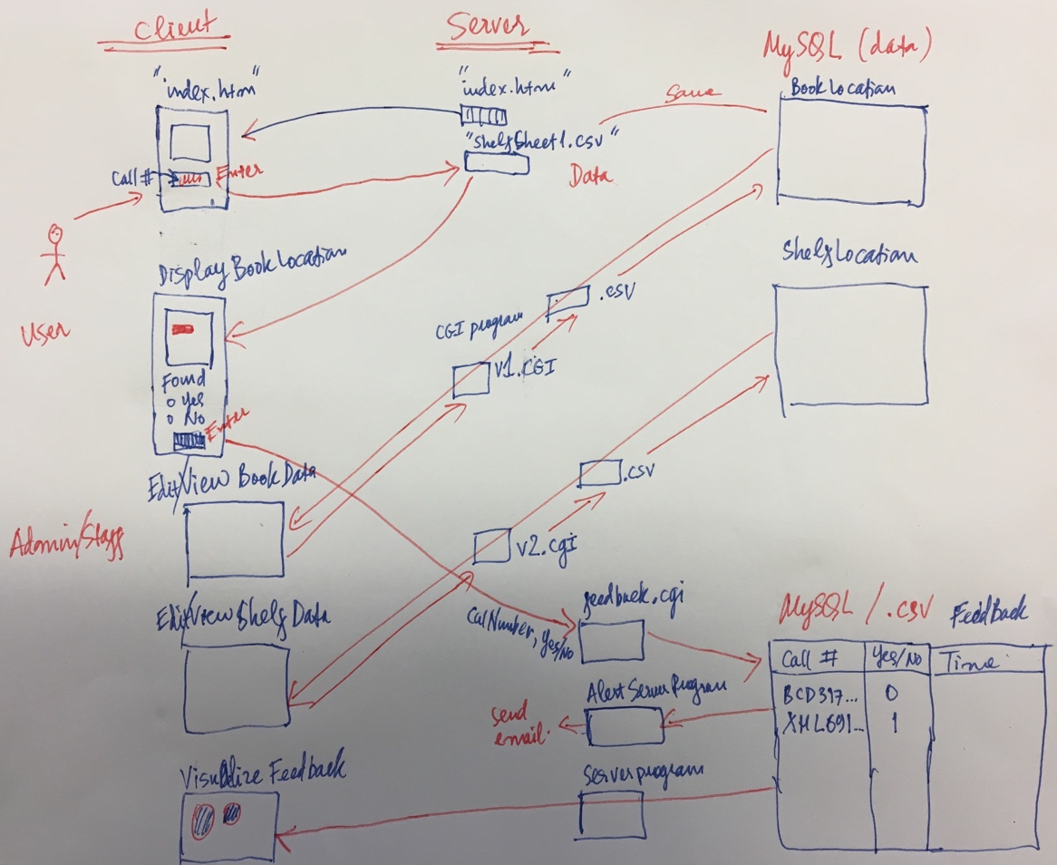

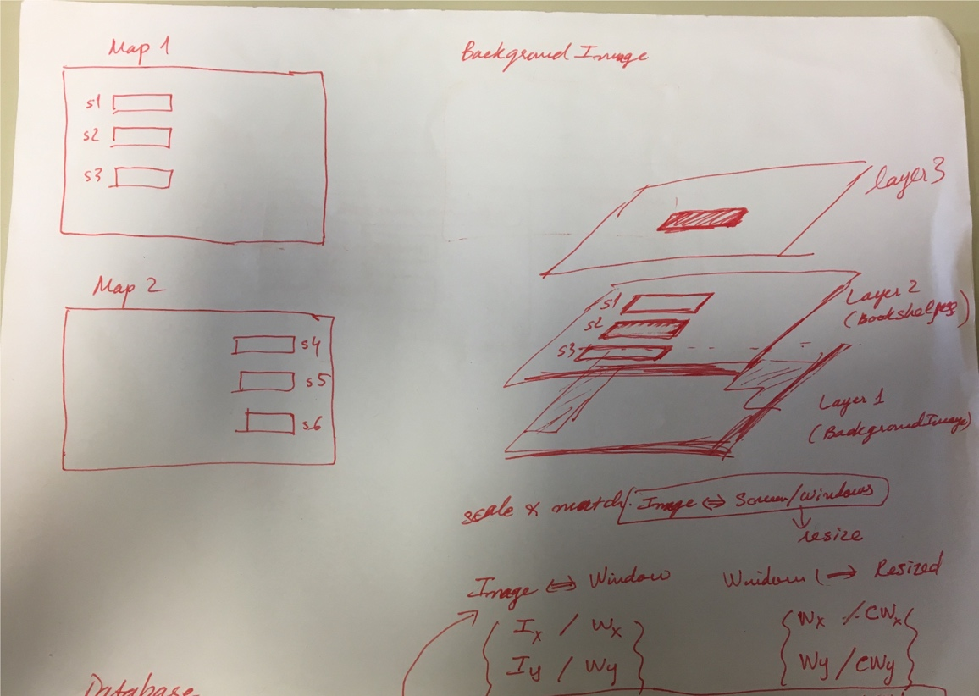

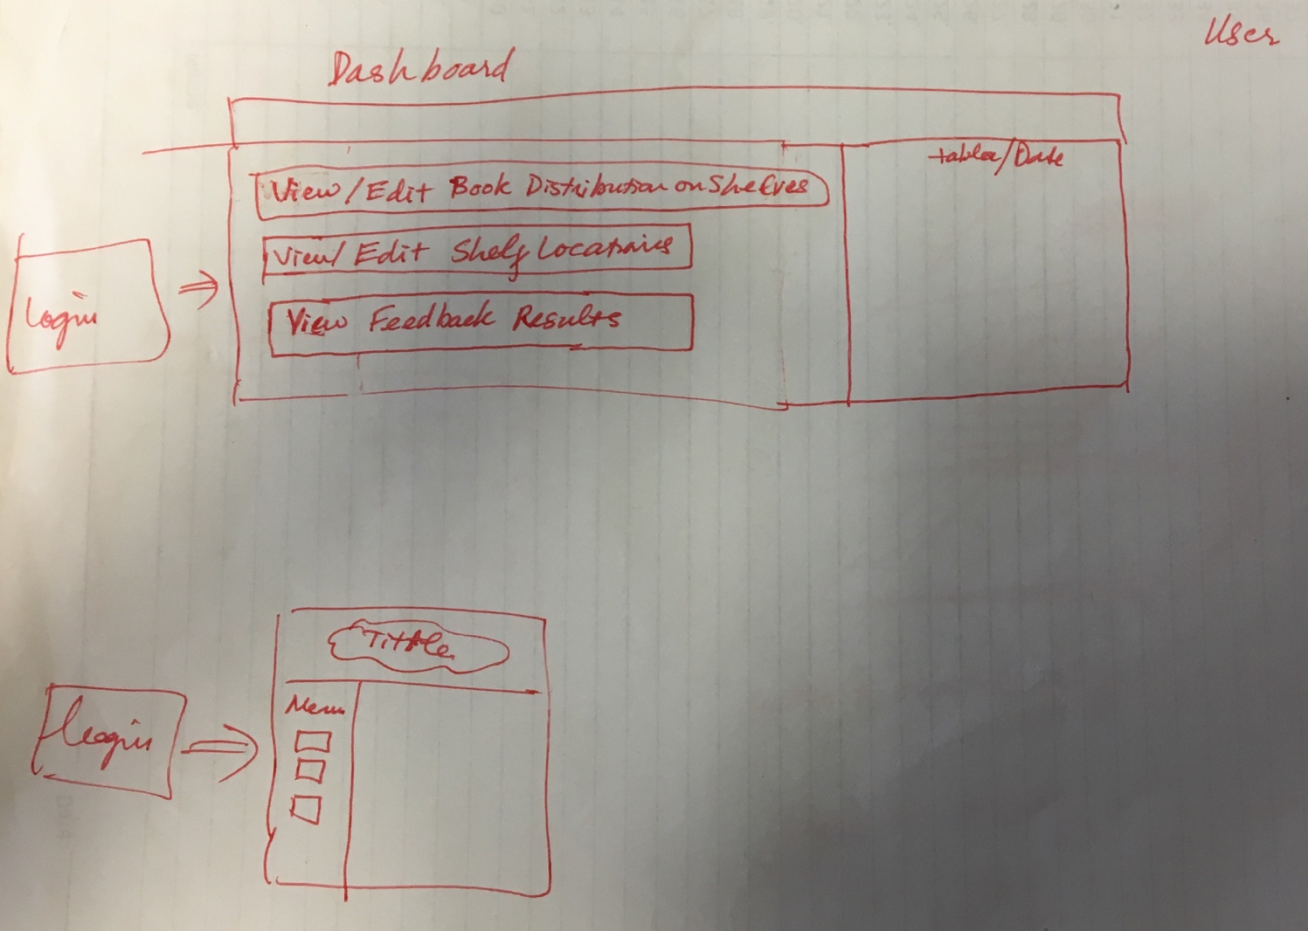

3.2 Components:

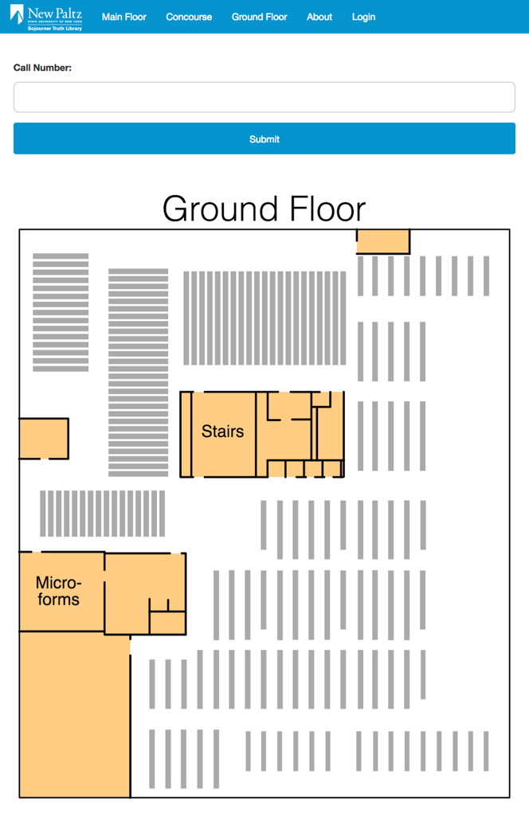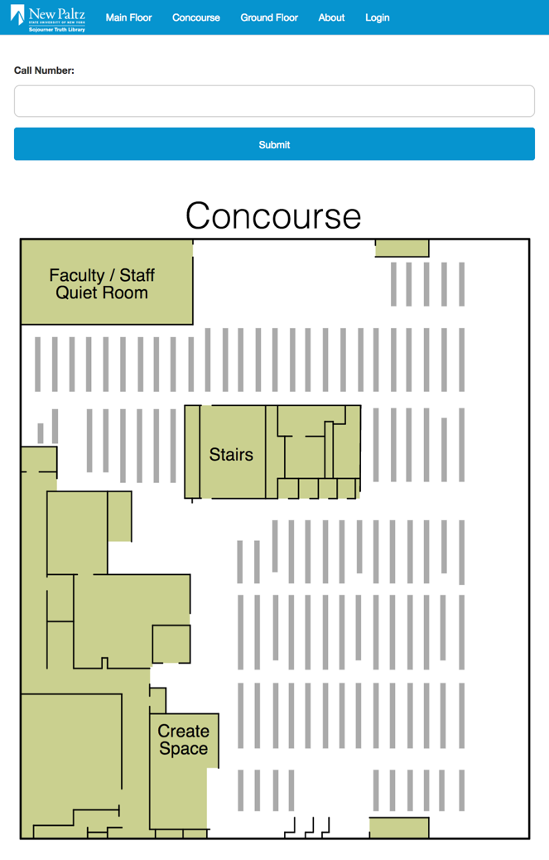

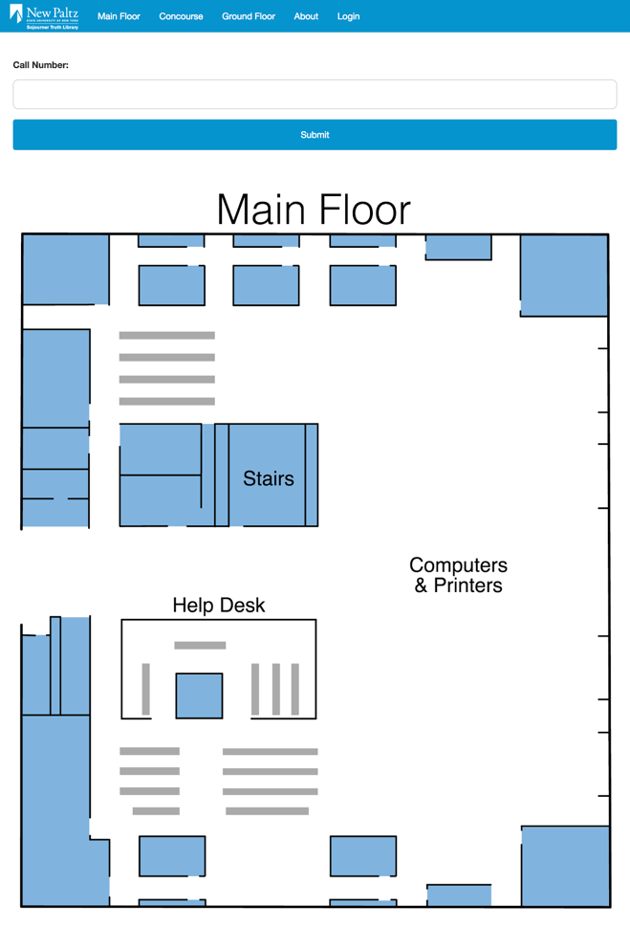

* Search box for call numbers
* Map of each floors
* Dynamic layers for:
  + Map Constants
  + Shelves
  + Shelf Coloring

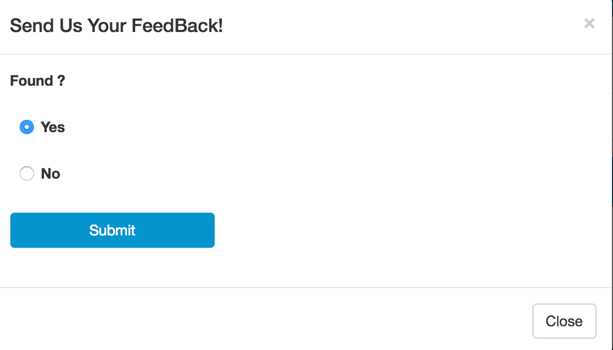

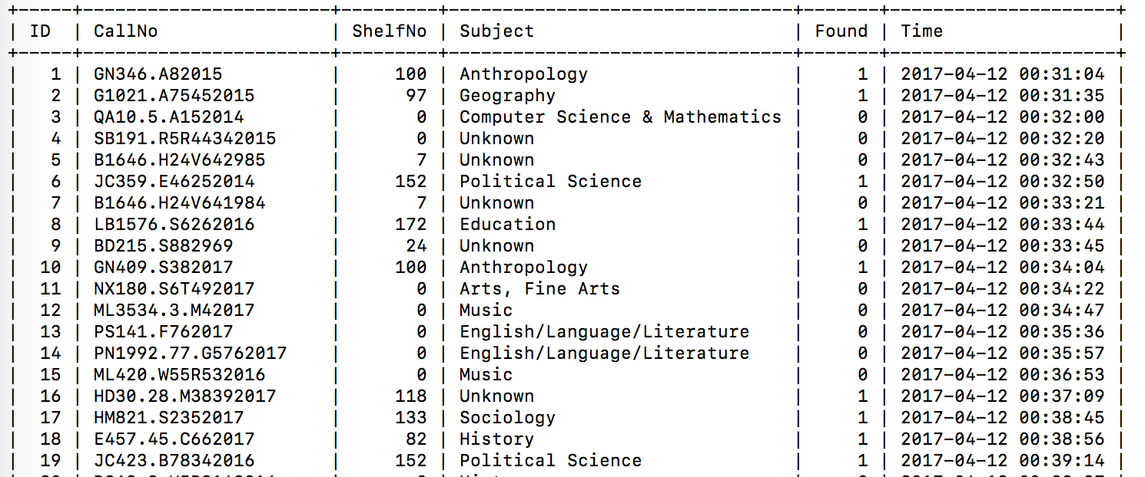

**Send Feedback Module:**

Once feedback is sent, the call number will be entered into the database, along with the subject and shelf number associated with it.

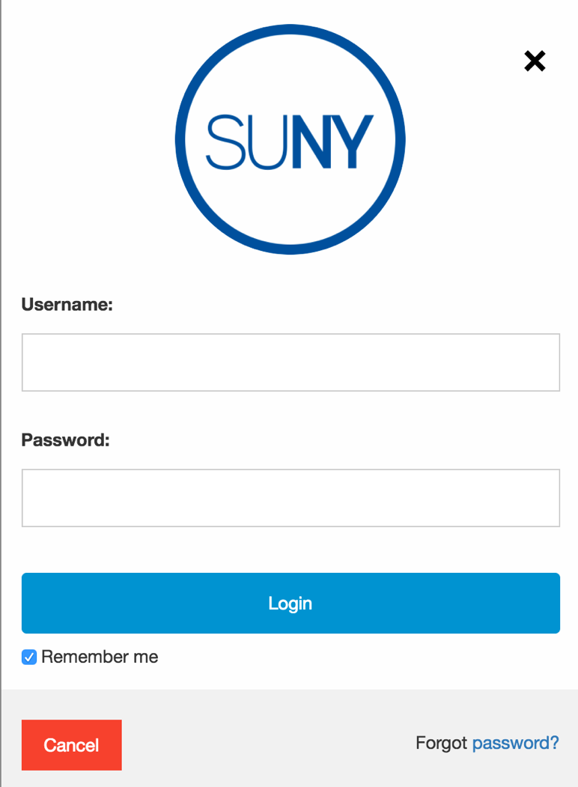

* Login Module
* Administrator Panel

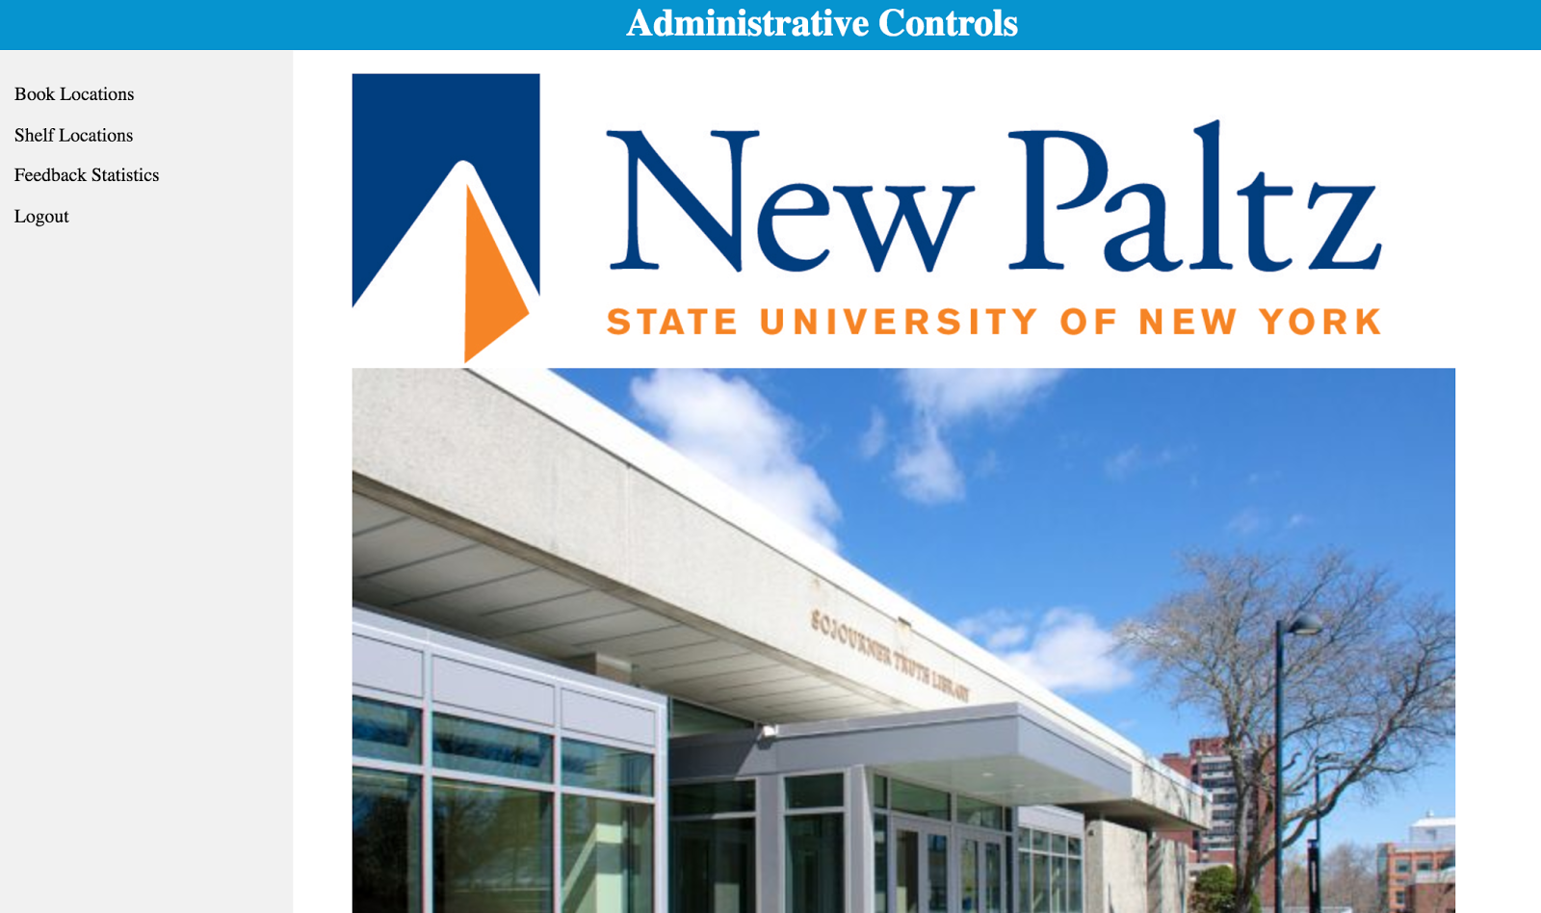

* **CRUD Database Management system:**

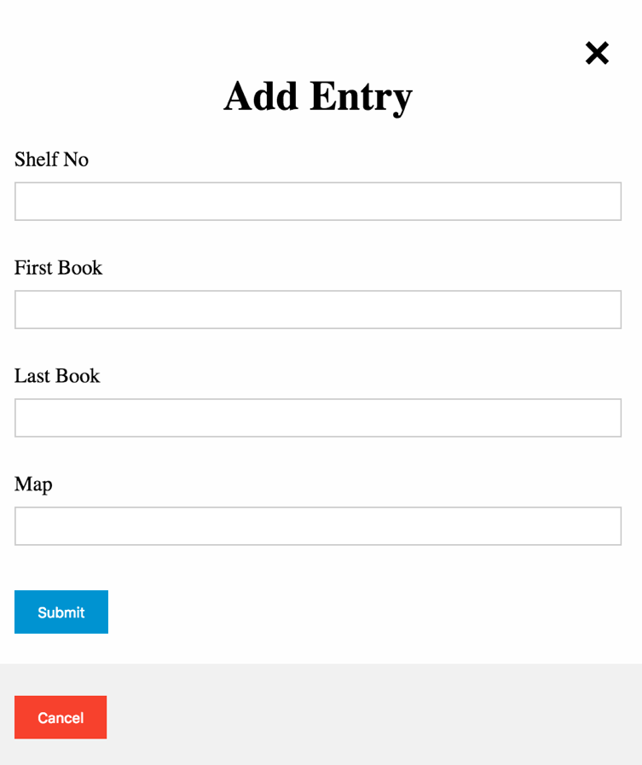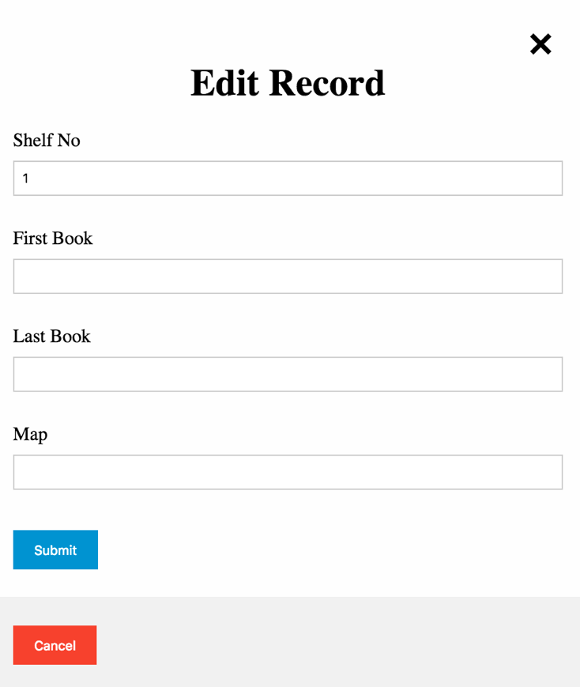

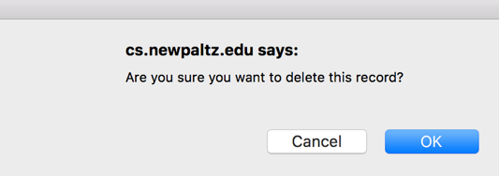

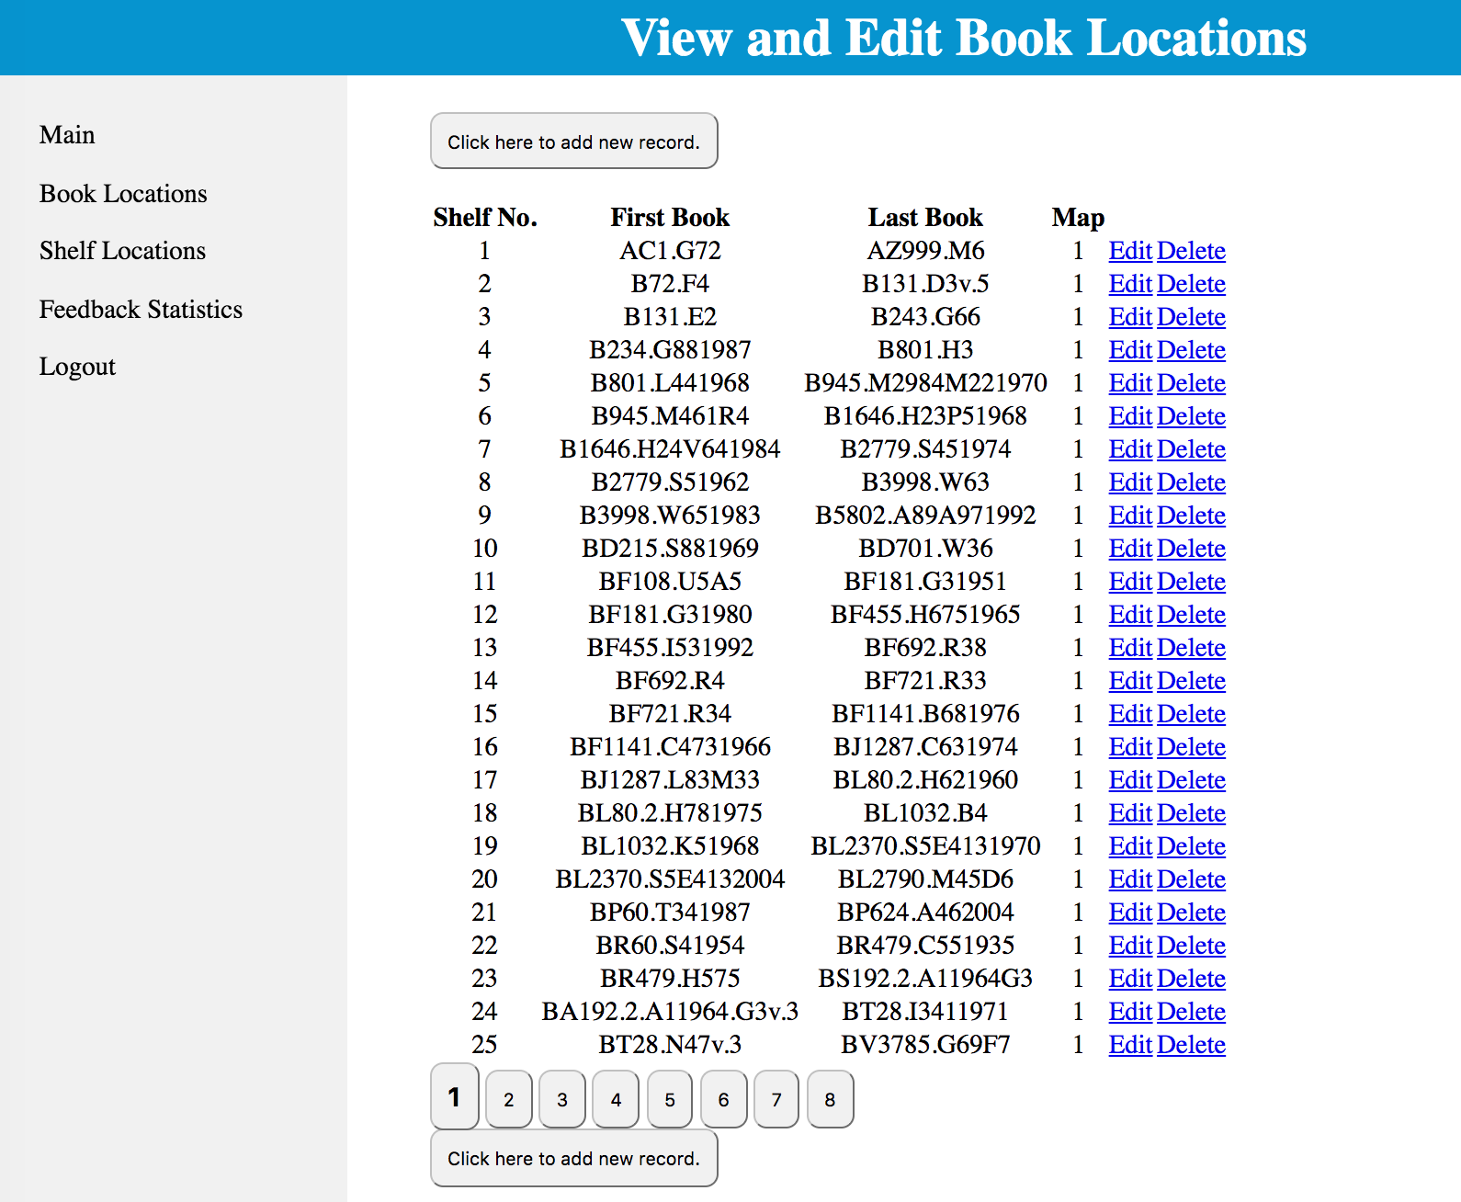

* **Data Visualization:**

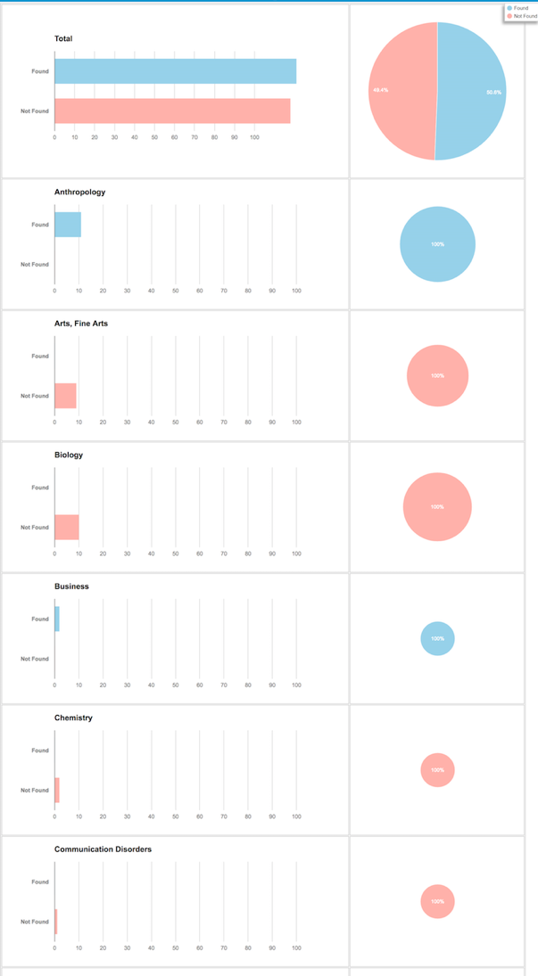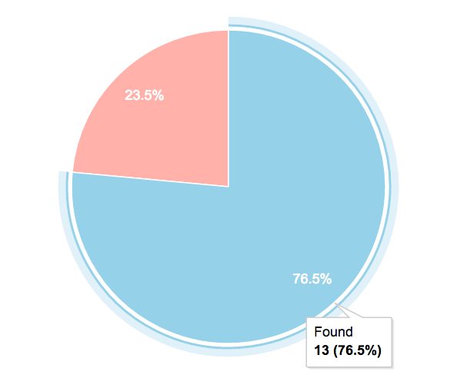

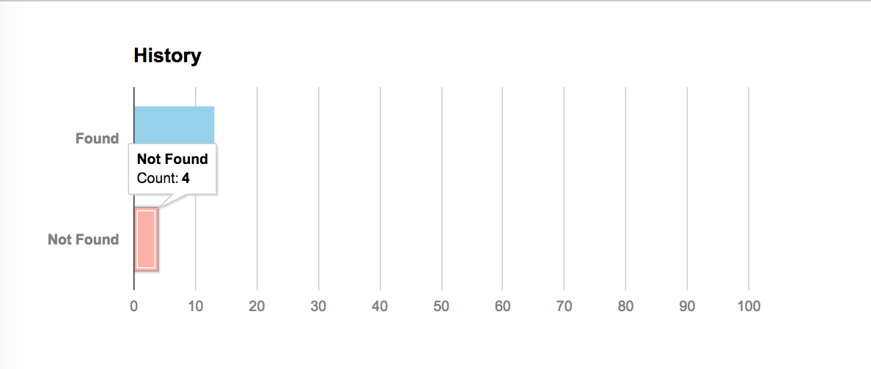

**4) Software/System Description:**

Library Map Application allows a user to search a book’s location within the library shelves. The application starts by receiving a call number entered by the user. The application then finds the shelf number of the shelf containing book. It does this by finding the shelf with a range of call numbers that the user entered call number resides in. The application then colors the correct shelf on the map and then sends feedback based on subject, found or not found, etc.

**5) Test Results/Observations:**

We began testing by feeding several real call numbers as well as fake ones into the application. We observed how it logged the feedback ad well as whether it colored the correct shelf or not. We found the application to be running as expected. We also tested the functionality of the MySQL database tables to ensure that the data was added correctly. The functionality of the newly designed admin page was also tested and proved to function as expected.

**6) Professional and Career Benefits:**

The Library Map Application has many professional and career benefits. The Sojourner Truth Library Administration hopes to present the application to other SUNY library administrators. In addition, to use by other SUNY campuses, the application can be implemented for use in other private libraries. The application allows for smoother locating of books within a library. The Library Map Application streamlines the book locating process for the user.

**7) Conclusion:**

For the Library Map Application, we started with a previous version of the application by a previous developer. From there, we redesigned the map to make it more dynamic by creating separate layers for the map backgrounds, selves, and coloring of the shelves. We also designed an administrative page to read feedback data, add, edit, and delete entries to the database tables which hold the data for the shelves. The Library Map Application is now more dynamic and allows for easy changes to shelf and book locations. The application was streamlined and made easy to use.

**8) References:**

Previous Developers:

* Anthony Giordano
* Brendan Wrafter
* Darrell Maxwell

Current Developers:

* Lee Miller
* Hui Li
* Andrew Smith
* Linna Chen

Graphics by Kelly Mclnerney